Contents

Purpose of this course 2
What is technical analysis? 3
The various type of charts – line, bar and candlestick 4
The candlestick – what does it look like, the components and the various types of candlesticks 7
Moving averages – what are they and how to read them? 18
What is golden cross and death cross ? 21
Oscillators – Stochastics – overbought and oversold indicators 22
MACD – Moving average convergence and Divergence 23
Support and resistance 24
Trend lines – what are they and how to spot trends – moving up , down or in a range ? 25
Candlestick Continuation Patterns 26
Candlestick reversal patterns 30
How to make money in any direction - up, down or sideways 32
How to control your emotions 34
Rules of money management 35
Always trade with a stop loss 36
How to use a stop loss when the trade is moving in your direction 37
Decide when the profit you have earned is enough – don’t get too greedy 38
Don’t invest or trade in something you don’t understand 39
Golden rule – kill the losses fast, let the profits run 40
Common Terms and major brokerages in India 41
Where to find the values of all commodities, currencies, economic news 43
Good habits in trading 44
Bonus Topics – The cost of opportunity 45
Bonus Topics – Good Personal Habits 47
Bonus Topics – Keep all your important documents in one place 48
About us – Wealthci.com 49
Wealthci.com – Other courses 50

Purpose of this course

The purpose of this course is to teach you technical analysis for trading in stocks, commodities, currencies

What is technical analysis?

Technical analysis is the study of charts
Every day the stock market makes various moves
Some stocks move up, some move down, some stay where they are – no movement from the previous day
Technical analysis studies the price trends over a long period of time and tells you which stocks are in
An uptrend – so you can buy these stocks for a long term
A downtrend – so you can SHORT (sell first at a higher price and then buy back at a lower price)
Technical analysis is not limited to just stocks, it can also be used to analyse trends in
- Commodities
- Currencies
- Crypto Currencies like Bitcoin , Etherium
- Options

The various type of charts – line, bar and candlestick

Line graph
This is what a line graph looks like – it is a simple to read

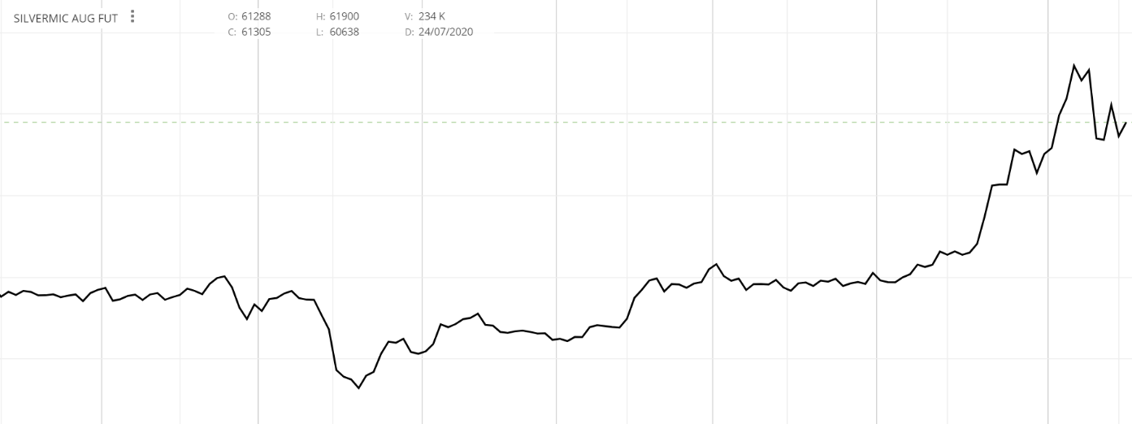

Bar graph
This is what a bar graph looks like – it indicates the low , high , open and close price
A bit more informative . Please notice that
- the red colour indicates that the closing price was below the opening price
- the green colour indicates that the closing price was above the opening price
(the red and green colours indicators indicate something similar to a traffic light – red means stop , green means go )

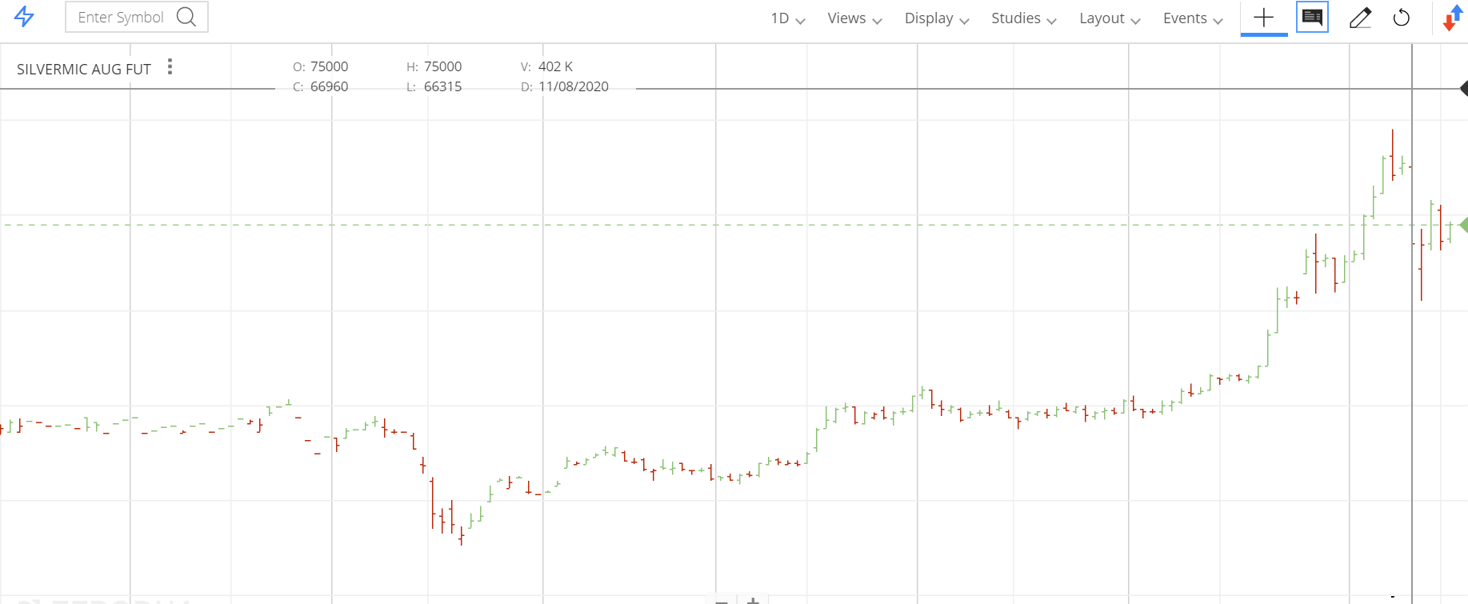
Candlestick graph

also indicates open, close , low and high prices , but it is much easier to read than the bar chart ..
The colour indications are also the same – red means closing price was less than opening price, green means closing price was higher than the opening price.

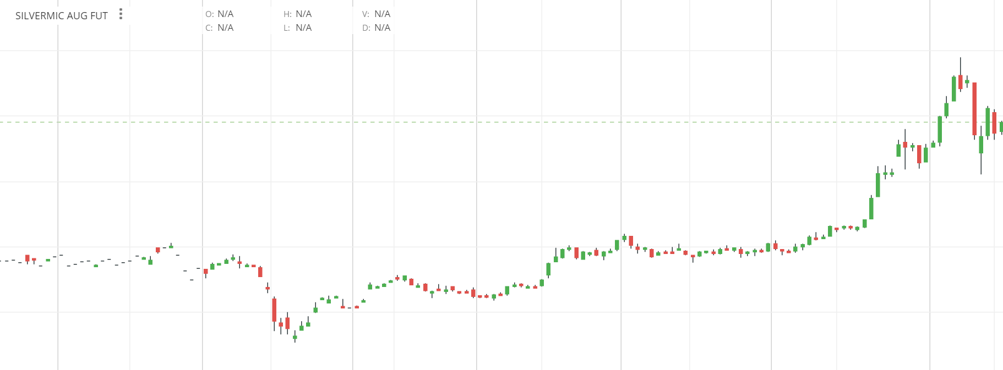

There is a nice history about candlesticks – they were used by the japanese since over 200 years ago for the price history of rice.

Since the candlestick charts are the easiest to read, we will continue with them only.

The terms – bulls and the bears

Bulls or bullish means that the market is in positive mood - the prices are increasing .

Bears or bearish means that the market is in a negative mood – the prices are decreasing

The candlestick – what does it look like, the components and the various types of candlesticks

This is a green candlestick – which means that the closing price was higher than the opening price.
The lowest price or the low is at the bottom of the candlestick and the highest price or the high is at the top of the candlestick.

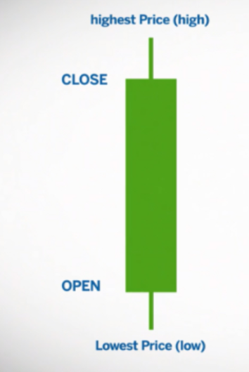
The vertical line towards the lower end of the candle is called a wick – it is there since the price moved up from the low to the close of the day

Similarly, the vertical line near the high of the candlestick is also called the wick - means that the price fell from the high to the close of the day.

The buying pressure comes from the bottom of the candlestick and the selling pressure comes from the top of the candlestick.
This candlestick is a red candlestick – meaning that the closing price was lower than the opening price

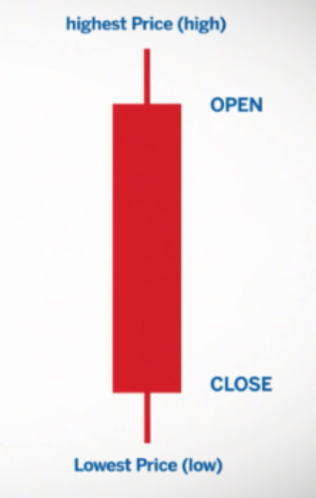

The vertical line towards the lower end of the candle is called a wick – it is there since the price moved up from the low to the close of the day

Similarly, the vertical line near the high of the candlestick is also called the wick - means that the price fell from the high to the close of the day.

The buying pressure comes from the bottom of the candlestick and the selling pressure comes from the top of the candlestick.

Here is another candlestick – it is called the bullish marubozu – a full candle with no wicks (lines on top or bottom)
the green colour indicates that there was a lot of buying pressure


Similarly, here is another candlestick, it is called the bearish marubozu , a full candle with no wicks ( lines on top or bottom)

the red colour indicates that there was a lot of selling pressure

Here are some other single candlesticks that we can observe in technical analysis ..

bullish hammer



This indicates that the price went down a lot and then the buyers came in and pushed the price up .. the long wick ( the line at the bottom ) indicates buying pressure

This candle is considered a bullish candlestick

The colour of the candle could be green or red – it does not matter … what matters is that the buyers are interested in the price at the lower end of the wick

bearish hammer or the inverted hammer



this candlestick is a bearish candlestick .. it indicates that the selling pressure is huge at the highest point of the candle

the candlestick colour can be red or green .. it does not matter … what matters is that the sellers are back.

the reason it is called an inverted hammer is the shape of the inverted hammer.

doji

a doji candlestick refers to indecision - means that opening and closing price remain very close to each other

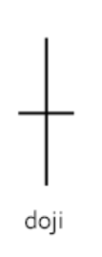

for example, look at the candle above – the opening and closing price remain at the same value .. you cannot tell by looking at the candle if it was a bullish day or a bearish day .

here is another variant – called the gravestone doji .. the price went up .. but then came down again .. indicates selling pressure

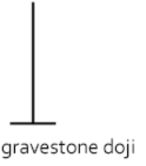

dragon fly doji

this is another variant of the doji – but this one has a positive or bullish bias …

the price went down, but the buyers came in and took it up .. the closing price and the opening price are the same

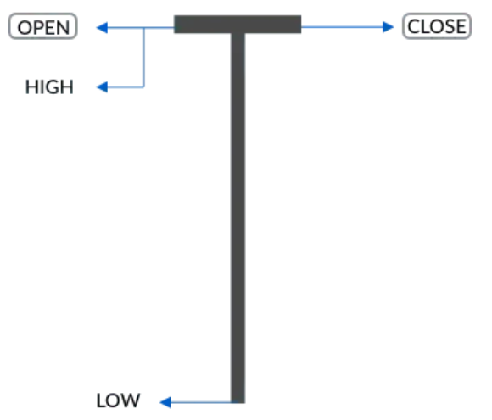

spinning top

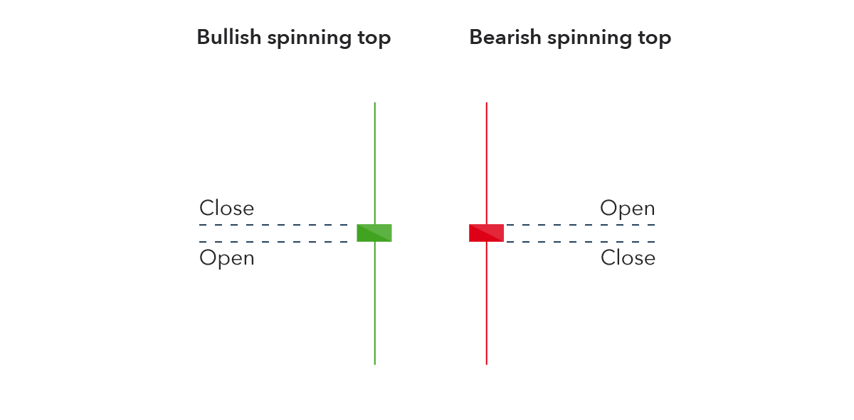

A spinning top candlestick is where the bullish and bearish forces are evenly decided.

If the colour of the candlestick is green , means that the close was higher than the open and the bulls won

If the colour of the candlestick is red , means that the close was lower than the open and the bears won

hanging man

a hanging man candlestick is generally considered a bullish candlestick, it has a long shadow and can be a green or red colour.. the shadow length indicates that buying pressure is strong

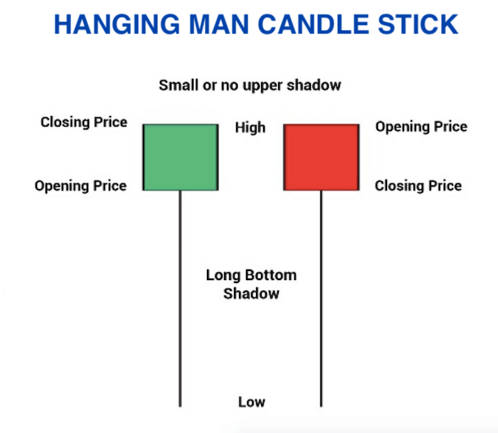
If the closing price is higher than the opening price, it has a green colour
If the closing price is lower than the opening price , it has a red colour

shooting star
the shooting star candlestick is the opposite of the hanging man candlestick

this candlestick has a long upper shadow – indicates selling pressure , the close could be a red or a green candle .. depends on where the open and close is
but generally it is a considered a bearish candle

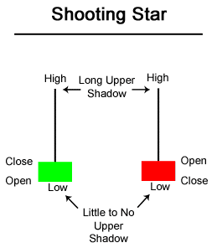

Moving averages – what are they and how to read them?

As prices move up or down , there are indicators called averages that you can use to track the price movements.

In the olden days , you had to calculate the prices manually ..

Today , you have these charting tools that can give you these prices at the click of a mouse button.

You can draw a chart – candlestick chart and see the moving averages – moving up and down with the chart movements …

You can draw these lines in various colours – e.g. if the faster moving average is moving faster than the slower moving average , it is a buy signal … you can buy when the faster signal crosses the slower indicator and moves up …

Typical examples for long term moving indicator values are 50 days and 200 days simple moving average.

There is a difference between simple and exponential moving average – the simple moving average moves slower than the exponential moving average.

Typically people use different colours to draw the moving averages – 50 days average is green colour and the 200 days average in red colour

This way , when the green average moves above the red average , you know it is time to buy and when the red indicator moves below the green indicator , it is time to sell – or exit the trade.

Please find below a candlestick chart with a slow and a fast moving average - in red and green colours

This is a chart of silvermic – the commodity chart from zerodha ..a leading broker in india ..

If you are not from india or don’t have access to zerodha , please don’t worry – you will find comparable brokerages with drawing tools elsewhere as well.

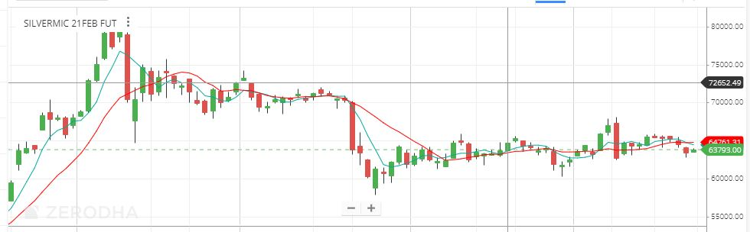

What values to use for moving averages ?

For long term traders , the following values work well

50 days Simple Moving Average ( SMA )
200 days Simple Moving Average ( SMA )

For short term traders , the following values work well

5 days Exponential Moving Average (EMA)
13 days Exponential Moving Average (EMA)
26 days Exponential Moving Average (EMA)

You buy when the 5 days EMA crosses the 13 and 26 days EMA going up
and sell when the 5 days EMA crosses the 13 and 26 days EMA going down.

What is golden cross and death cross ?

- What is golden cross

The point where the 50 day simple moving average ( SMA ) crossing the 200 day simple moving average ( SMA ) from bottom and goes up … is called the golden cross – the name says it all – it is a golden time to buy …

- What is death cross

The point where the 50 day simple moving average ( SMA ) crossing the 200 day simple moving average ( SMA ) from top and goes down … is called the death cross – the name says it all – it is a time to sell ..

Oscillators – Stochastics – overbought and oversold indicators

Now that we have looked at moving averages, let’s look at some of the other tools that are available on charts that can help you trade

One of them is an oscillator – called stochastics

An oscillator is very similar to what you had learnt in high school physics – it consists of sine wave like graphs

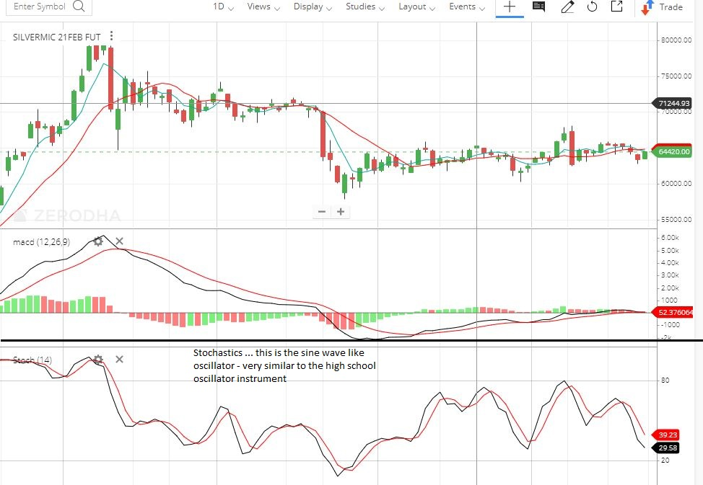
Here is the oscillator – you will notice that when the value gets near about 80 - it becomes overbought – which means that there are too many buyers and a fall is likely .. get out of the buy trade ..

You will also notice that around 20 – 25 is the point where the indicator indicates an oversold value – meaning that the buying price is good .. a good opportunity to buy.

It is safe to say : buy when the stochastics is near 20 and sell when it is close to 80 and you will benefit from the trade..

MACD – Moving average convergence and Divergence

Here is another oscillator called MACD – Moving average convergence divergence : the rate at which the moving averages converge ( move towards ) and diverge ( move away ) from each other.
It is another tool available in brokerages .. – you can point and click and select the tool to place it anywhere for any commodity / stock / currency …

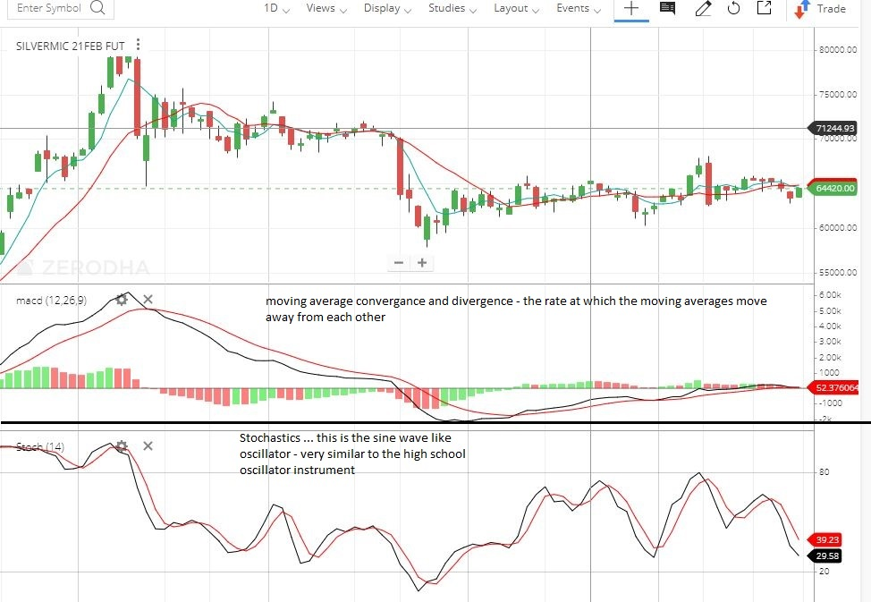

It shows the rate of divergence ( or movements away from each other ) of the moving averages

Support and resistance

Support is a point where the prices have historically jumped up from … it Is called the buying zone

Typically, in a chart , you will see the horizontal line from where the prices have moved up – It is also the point where buyers come in

Here is the chart where the you can see the buyers come in and the prices moving up.

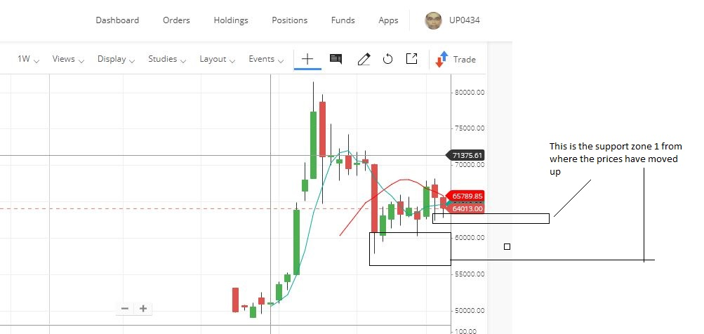

Now , we will see the resistance zone .. where the levels from where the prices fall – please see the level at the top ..

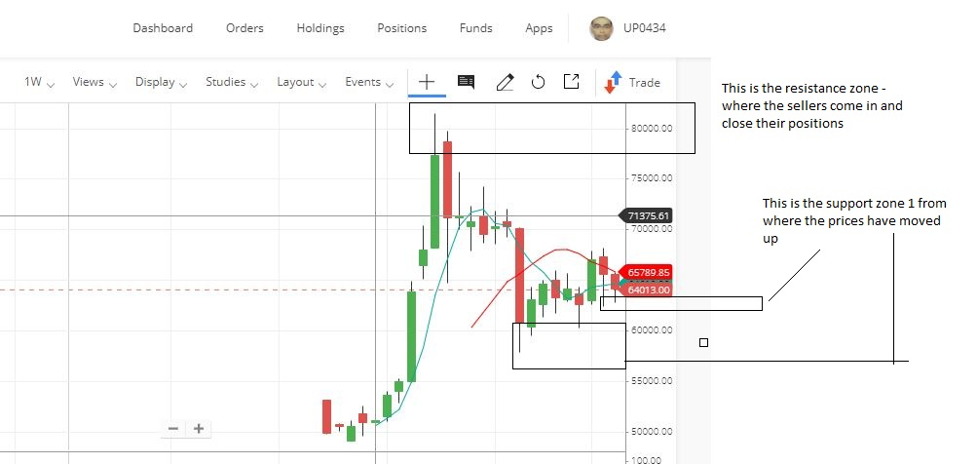

Trend lines – what are they and how to spot trends – moving up , down or in a range ?

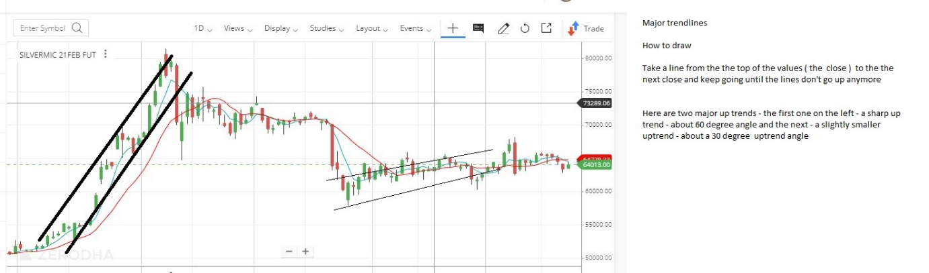

Trend lines tell you how to trade – the graph above tells you how to spot an uptrend – we can see two uptrends – first a sharp one and the next a slightly smaller one.

The chart down is a down trend

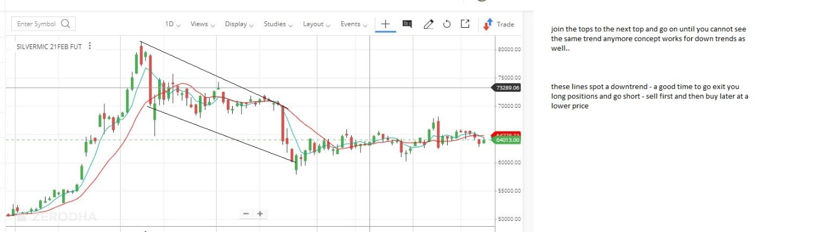

Candlestick Continuation Patterns

Flag up and Pennant Pattern

If you have seen a flag and a pole that hangs the flag , this pattern looks like this
It has a movement up , then some consolidation and then another movement up ..
The second movement up takes up in about 1/3rd of the time in the flag phase.
The projected target is the same amount as the first movement. 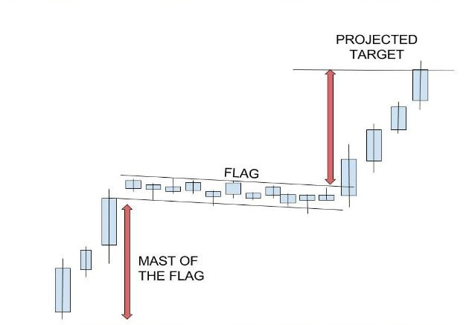

Here is another variation of the bullish flag
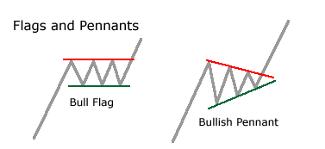

Here is another variation:

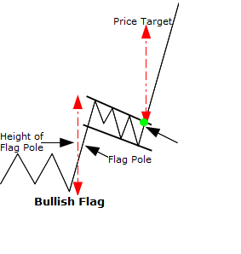

Flag Down Pattern

The opposite of that is the flag down pattern , where the initial movement is down , and there is a consolidation for some time and when that consolidation ends , the next leg of the downwards movement starts …

Here are some sample bear flags … it is the time to make money shorting the stock - selling it first and then buying it later at a lower price..

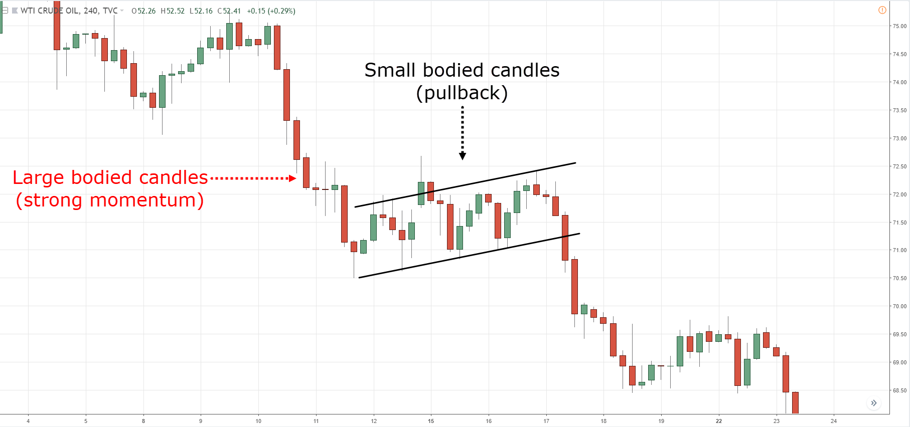

The second downward movement comes in one third of the time as compared to the first movement.

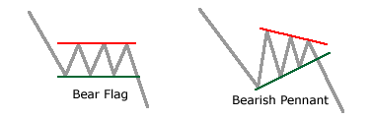
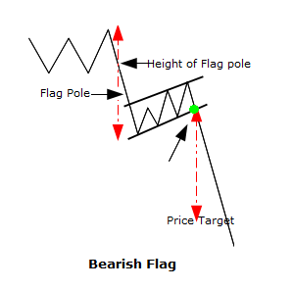

Candlestick reversal patterns

- Here we will look at two patterns that are of type reversal :
Let’s look at some of the reversal patterns – these tell you that the patterns are about to reverse..

Here is a head and shoulders pattern – the price moving up , till it cannot move up anymore , the next up move is not so strong and the reversal happens
The target price during the fall is also shown
The price target is the distance from the head to the neckline
This pattern is very similar to the human body - head and shoulders 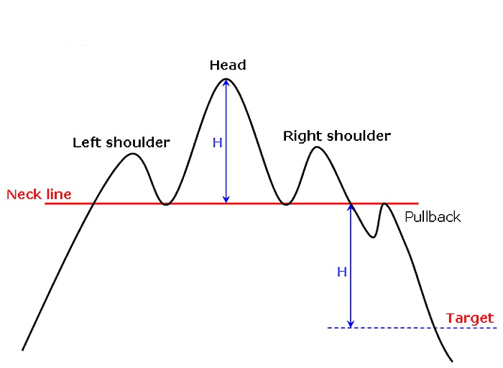

The next pattern is the reverse head and shoulders pattern or the inverse head and shoulders pattern

This occurs at the end of a downturn or a down move … the price moves down , then another down move – which cannot be held or sustained for long and the reversal happens…
The trend is like the inversal head and shoulders of the human body.
The target is also defined like the head and shoulders technical chart..

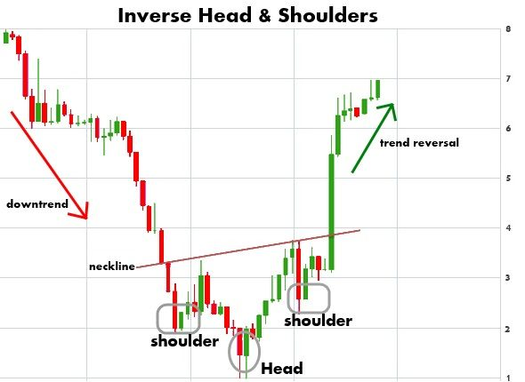

How to make money in any direction - up, down or sideways

When markets are going up , you can make money buying low and then selling high – this is called being long
The markets will be making higher lows and higher highs …
The candlesticks will be green in colour.

Below is a screenshot of an uptrend

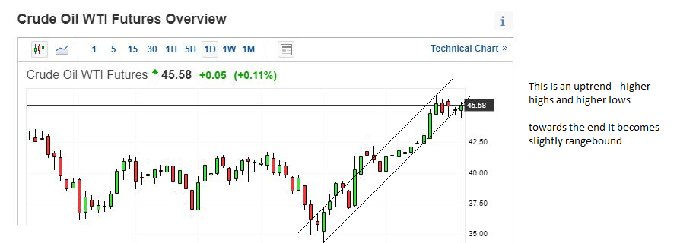

When the markets are going lower, the candlesticks will be red in colour, you can make money by shorting – selling first at a higher price and then buying at a lower price
The market will be making lower lows and lower highs.

When the market is in a range , you will be able to see it – you can buy it at the lower price and sell it at the higher price

Below is a screenshot of the downward trend followed by a sideways trend , a consolidation
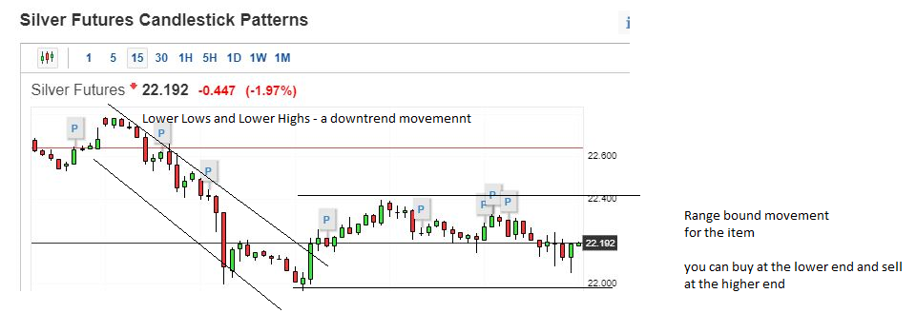

How to control your emotions

When you start a trade, there are three things that can happen

The trade goes your way, your profits starts increasing .. in this case , you should use a trailing stop loss to protect your profits … and keep moving it up as the profits start increasing…

The trade goes against you – in that case you decide on the max loss and get out of the trade

The trade stays in a range – in which case you wait for the trade to increase your profits and protect your profits with a stop loss

What is a stop loss ?
A stop loss is just the same – it protects your losses from increasing ..

Before you start a trade, you decide on the max loss that you are willing to take on that trade .
If you are going long ( buying low first , selling high later ) , and you decide that your max loss will be 400 inr, you place the buy order .. once executed , you execute a sell order at 400 below the buy price – this order type will be a stop loss order with the sell price and the trigger price of 400 inr below the buy price.

If you are going short ( selling high first , buying low later ) , and you decide that your max loss will be 400 inr, you place the sell order .. once executed , you execute a buy order at 400 above the sell price – this order type will be a stop loss order with the buy price and the trigger price of 400 inr above the sell price.

Rules of money management

The following rules should be followed while trading

Never trade with more than 5 % of your total trading capital in one trade ..
Eg if your total trading capital is 100,000 , your capital used per trade should be max 5,000

Always trade with a stop loss
The max loss you should be willing to take should be 2 % of your trade amount … eg if you have traded with an amount of 10,000 in that trade ,the max loss should be 200 ..

Always trade with a stop loss

What is a stop loss ?
A stop loss is just the same – it protects your losses from increasing ..

Before you start a trade, you decide on the max loss that you are willing to take on that trade .
If you are going long ( buying low first , selling high later ) , and you decide that your max loss will be 400 inr, you place the buy order .. once executed , you execute a sell order at 400 below the buy price – this order type will be a stop loss order with the sell price and the trigger price of 400 inr below the buy price.

If you are going short ( selling high first , buying low later ) , and you decide that your max loss will be 400 inr, you place the sell order .. once executed , you execute a buy order at 400 above the sell price – this order type will be a stop loss order with the buy price and the trigger price of 400 inr above the sell price.

How to use a stop loss when the trade is moving in your direction

When you start a trade, there are three things that can happen

The trade goes your way, your profits starts increasing .. in this case , you should use a trailing stop loss to protect your profits … and keep moving it up as the profits start increasing…

The trade goes against you – in that case you decide on the max loss and get out of the trade

The trade stays in a range – in which case you wait for the trade to increase your profits and protect your profits with a stop loss

Decide when the profit you have earned is enough – don’t get too greedy

When the trade starts going in your favour, you have to do two things

1.put a trailing stop loss, close to the current price
2. decide on how much profit will be enough

It is imperative that you exit the trade while it is still on your side – because trades can reverse pretty fast , specially volatile ones ( where price movement goes up and down )

Don’t invest or trade in something you don’t understand

This is a golden rule – if you are trading a stock or commodity or a currency, do you understand what drives the price upwards ?

What are the factors causing demand to rise and hence the price ?

Study the trends , read as much about the trades and the demand and supply factors before trading or investing in the item.

Golden rule – kill the losses fast, let the profits run

Please don’t let ego get in the way of trading – get out of a losing trade, ride the winners for as long as you can ..

Please protect with stop losses – both your profits and your losses

Common Terms and major brokerages in India

Major brokerages in india
- Zerodha
- Sharekhan
- IIFL
- Angel broking
- Kotak
- Axis
- Motial Oswal

What is margin money?

Margin money is the amount that your brokerage will ask you to have in your trading account for taking the trade .. for stocks in cash , it is generally the price of the share
For currency and commodities, it is decided by the combination of the trading exchange and the brokerage .
The brokerage amount would be charged per trade as well – some brokerages have a flat charge per trade , others charge a percentage .

What is market price order?
When you want to trade the stock , currency or commodity at the current price of the item , you use the market price order . This will trade the item immediately at the current price

What is a limit price order?
When you have a particular price in mind to trade the item ( stock , commodity or currency ) , you place a limit price order .. your order will be executed only at that price
What is a stop loss ?
A stop loss is just the same – it protects your losses from increasing ..
Before you start a trade, you decide on the max loss that you are willing to take on that trade .
If you are going long ( buying low first , selling high later ) , and you decide that your max loss will be 400 inr, you place the buy order .. once executed , you execute a sell order at 400 below the buy price – this order type will be a stop loss order with the sell price and the trigger price of 400 inr below the buy price.

If you are going short ( selling high first , buying low later ) , and you decide that your max loss will be 400 inr, you place the sell order .. once executed , you execute a buy order at 400 above the sell price – this order type will be a stop loss order with the buy price and the trigger price of 400 inr above the sell price.

What is positional trading ?
Positon trading takes into an account a long time view of the item – be it a stock , commodity or currency
It does not worry about the daily price movements at all
This is also called investing for the long term

What is swing trading ?
Swing trading takes advantage of the short term positional movements – using daily trends or weekly trends to book profits in the trade
Technical analysis is used for this .

Where to find the values of all commodities, currencies, economic news

For international prices of commodities and currencies and news , you can view the following sites

- www.Investing.com
- www.Bloomberg.com
- www.Cnbc.com

For local prices , you can see them in your brokerage itself ..

For commodity news, typically the following news affects the movement of crude and natural gas prices

Wednesdays – Crude Oil inventories
Thursdays - Natural Gas inventories

What can you trade in India

- Crude Oil, Natural Gas on MCX – Metals and Commodities Exchange
- Precious Metals – Gold, Silver on MCX
- Other metals – Nickel, Aluminium ,Copper , Lead , Zinc on MCX
- Agricultural Commodities on NCDEX – a lot of them to list here

News that also move the market prices are the usa unemployment claims – released on Thursdays in the usa , jobs created the previous month in usa – released in the first week of the month for the prior month

Good habits in trading

Maintain a trading journal

List the trades taken here .. it should have

Date
Short or long
Why did you take the trade
Stop loss
Target
Profit or Loss
Amount of profit or loss

You can do it in excel – easy to tally up the profits and losses – keep a running total

Have separate tabs / sheets for each month

Decide on the stop loss and the target ( based on charts )

- Risk = absolute ( Trade price– Stop Loss price )
- Reward = absolute (Target Price – trade price )

Only take the trades where the reward to risk ratio is 3 to 1 or better, the higher the reward, the better.

Please leave yesterday’s trades behind

Please leave yesterday’ trades there, start each day fresh

Study the trend

This will take some practice – do some paper trading on charts – no actual money is involved – you just write the trades in an excel sheet –

For chart trends – take screenshots and open these in paintbrush tool or the drawing tools that come with charts of brokerages

Money Management

When you suffer a loss too many days in a row, stop trading .. wait for some days to clear your head … maybe the trend in which you were in has changed .. wait for some days to make sure the trend direction is known …

You will lose some money initially . .. that is part of your learning curve..

Bonus Topics – The cost of opportunity

Whenever you feel like spending on something, just follow these steps.

- Wait for 30 days, chances are you will not even think about it now.

- See how many hours you have to work for it – you know your yearly salary, divide it by 2000 and that is your hourly salary rate. Divide the cost of this item by your hourly rate. That is the number of hours you have to work for this item. Is it worth it?

- Take the calculator challenge. Use the compound interest calculator and see what will be the value of this money after 10 , 20 and 30 years.

- Assume that you would like to purchase a BMW car , worth 45 lakhs with a loan, a total cost of 50 lakhs . At the end of 10 years , this car will be worth 25 lakhs due to depreciation , but use the calculator ( compounding one ) to see what the value of 50 lakhs will be after 20 years. Here it is.

- The calculator setup :

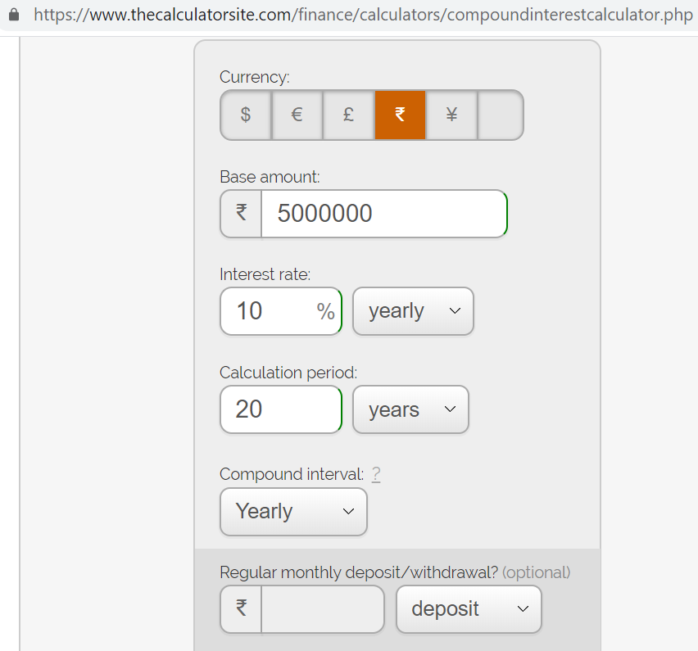
The calculator results.

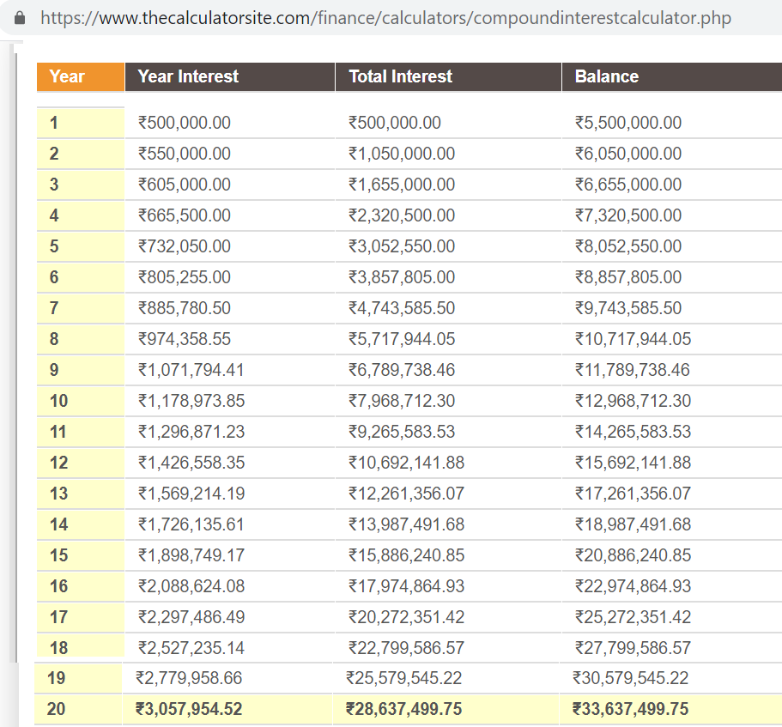

It is 3.37 crores – the car’s value is 25 lakhs – so you gain almost 3.12 crores investing the money at 10 % per year average for 20 years. it’s a no brainer really.

Use Uber or Ola or Carpooling or public transport ( the bus or the metro ) for the time you would like to go out somewhere far.

Bonus Topics – Good Personal Habits

- Take a shower / bath everyday
- Get a haircut every two weeks
- Wear a deodorant and have breath mints handy
- Be organized – carry a big notebook in your bag and a pen in your pocket
- Be early or before time – nobody likes to waste their time
- Comb your hair daily – trim your ear’s and nose’s hair
- When you see someone following you (and not tailgating in the office), hold the door for them
- When you see someone coming behind you, hold the elevator for them
- Keep an arm’s length from people – don’t measure it . Don’t invade their personal space
- Polish your shoes daily
- Get vitamin D daily - go out in the sun
- Take a small walk after lunch and dinner – will help in digestion of food
- Don’t multi-task – it is not useful
- Complete the difficult tasks / ugly tasks first. Makes the rest of the day easy
- Manage your time in 15 minute increments. See where it is going and then ration it
- Don’t pick your teeth or nose in public
- Don’t interrupt someone – let them finish what they are saying and then add your thoughts
- Be humble – there is a lot we don’t know – there is so much to learn from other people
- Be grateful – if you have a roof on your head, water to drink, food to eat, money in your bank, a job – you are better than 80 % of the other people.
- Practice random acts of kindness
- Give to charity, a person in need
- Donate online to charities like ketto.org – it is a crowd funding platform to give to people in need
- If your company has a scholarship fund for the needy children, contribute to it, a small amount by a large number of people will make a big difference.
- Invest in a good quality wardrobe – they will last longer and be cheaper in the long run
- Always wear a watch – it shows people you value time.

Bonus Topics – Keep all your important documents in one place

- Have a place in your cupboard / almirah with an important file

- List and contact numbers of your parents , siblings , important people to contact in case of an emergency

- List all your appliances - bills , invoices , warranties

- Your insurance documents - health , life , car

- Your will

- Your life insurance

- Passwords to your bank accounts, documents, policies.

- Your bank account details - account names, account numbers , branch.

- Your investments - fixed deposits, investment accounts, retirement documents etc..

- Your banking representatives in the bank branches

- Important details about your medical life - blood type, injuries, accidents, allergies (eg some people are allergic to milk, some to peanuts)

- Always have a health insurance policy

- Always a life insurance policy – make it a term life insurance – you will lose the money if you survive the period of the insurance – but that is not what this policy is for – it is in case you die in the period of the policy and your family members will get the amount of the sum insured.

About us – Wealthci.com

We are entrepreneurs at heart. This is our third start-up venture .
The first was a software development company in Mumbai , India . We provided software services to educational companies and a few radio stations .
The educational clients included Jetking , Informatics ( a franchise of Informatics Singapore ) .
The radio channels were Times FM , Radio Midday , known today as Radio Mirchi and Radio One .
Then we started a consulting business in the United States of America , provided services to clients like :
Harvard University - Boston
North-western University - Chicago
AT & T – Chicago
amongst others.
This is the third venture where we decided to give back to society .
Please learn from our two decades of experience in Startups , Marketing and Scaling your business
Oh yes, one more thing, we provided financial advice to IBM India Employees from 2011 to 2014.

Wealthci.com – Other courses

- Stock market. technical analysis
- Personal finance and planning
- Secrets of a successful business
- Backup and contingency planning
- Teach your kids about money
- How to ask for a raise / salary hike
- How to navigate office politics and come out ahead
- Soft skills
- Entrepreneurship
- All you wanted to know about Startups
- The business models of some popular companies
- Monopolies or Collaborations - what is the future ?
- How to get and maintain the first mover advantage (eg Apple Iphones)
- Generating capital through stock , currencies and commodities trading
- How to live for almost free from your first job till marriage (this one)
- Real estate
- How to grow and scale up your business
- How to attract and get the things you want from life
- The power of your mind - going to alpha waves state
- Disruption and how to disrupt existing business models
- How the top one percent (wealthy people) think and what they do
- Marketing on a small budget - leveraging social media
- Finding / Creating businesses based on non-existent markets - be a first!
- How to take advantage of the shared economy
- How to get the rich people mind-set
- How to register your business in India
- How to raise money
- How to fit into an upscale crowd
- Where do start up ideas come from
- The best time of the day to do certain tasks
- Movies from which you can learn about businesses
- Personal productivity tips
- Generating start-up ideas
- Developing patience - an essential trait for the stock market
- How to take advantage of the algorithmic trading in stocks
- Quant and Algorithmic Trading in Stocks
- Digital currencies (e.g. Bitcoin) and their future
- The future of bullion (gold, silver, platinum) - could they be the future currencies?
- Direct Marketing and Cold Calling
- The Apple marketing machine - what you can learn from them
- Stories from the best customer service companies in the world
- The future of social entrepreneurship - make money while helping others
An example, taking unused food from restaurants and hotels to food banks to feed the less fortunate

